EVENT DATE  Saturday, October 17, 2026 | HOURS  11:00 a.m.-5:30 p.m. | VENDOR FEE  $30
RAIN DATE  Sunday, October 18, 2026 | APPLICATION DEADLINE  August 31, 2026 | SPACE  Approximately 10' x 10'
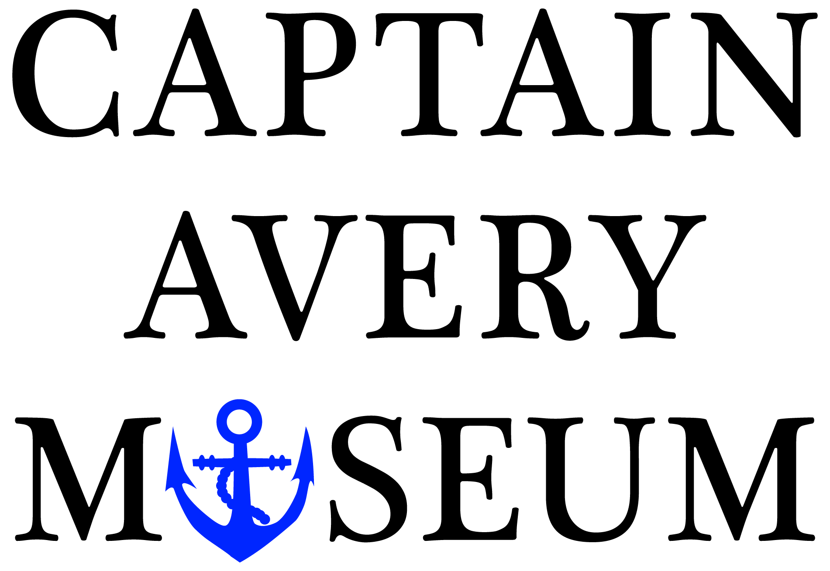
2026 OYSTER FESTIVAL
Vendor Information
Crafters | Artisans | Authors

Space, Equipment & Assignment
Vendor setup Vendors may bring and set up their own 10' x 10' tents.
Equipment available One 8' table and two chairs can be provided upon request.
Space assignment Spaces are assigned on a first-come, first-served basis after payment is received.

Festival Requirements
Booth staffing Exhibitors must staff their booths and remain present throughout the festival.
Sales and taxes Exhibitors are responsible for recording and reporting sales and for collecting and remitting all applicable sales taxes.
Approval All applications are subject to approval by the Captain Avery Museum Oyster Festival Committee.

Set-Up, Parking & Vendor Location
Unloading Vendors may drive onto the museum grounds to unload between 9:00 and 10:00 a.m. All vendor vehicles must be removed from the festival grounds by 10:30 a.m.
Parking Vendor parking is available in a nearby lot. Shuttle service will operate between the parking lot and the museum.
Booth location Crafters, artisans, and authors will be located in the museum's gravel parking lot near the festival entrance.
IMPORTANT RESTRICTION Food and beverages may not be sold or distributed as giveaways by non-food vendors.

Location & Cancellation Policy
Captain Avery Museum 1418 E. West Shady Side Road, Shady Side, MD 20764
Cancellation If the event is canceled for any reason, participant fees will be refunded.

